**Launch and Connect to an EC2 Instance**

We start with logging on to our **AWS Management Portal**

Now as we see this is our portal,

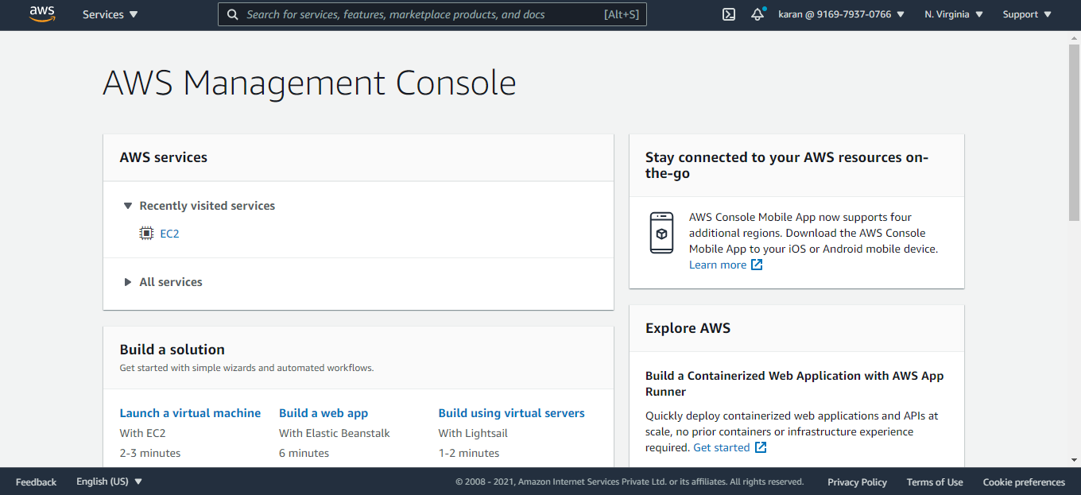

Now to proceed we need to go to the EC2 dashboard where we will be creating an Ubuntu Instance.

So clicking on the **EC2** **link** present on our AWS management console will redirect you to the **EC2 dashboard** which looks something like this.

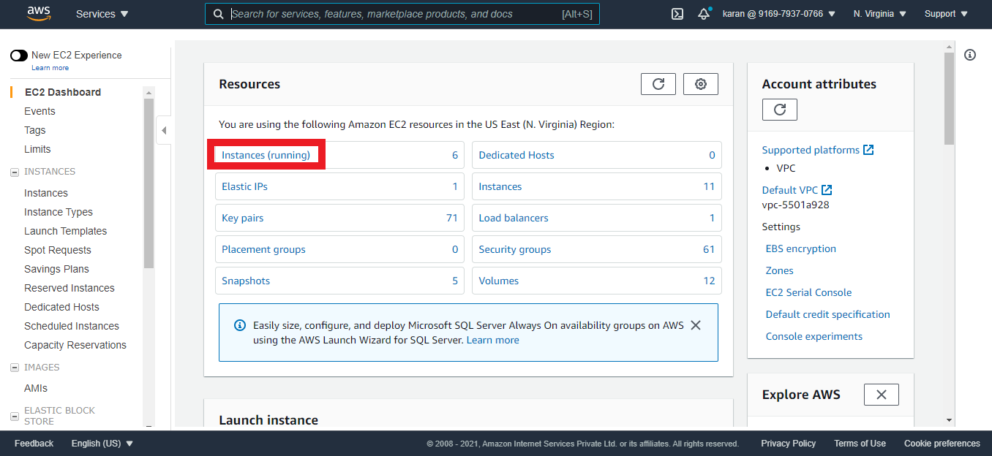

Here we can see the **Instances Running** link we can either click this, or we can use the **Instances link on the left**. This will lead us to the page where we will start creating our Instance.

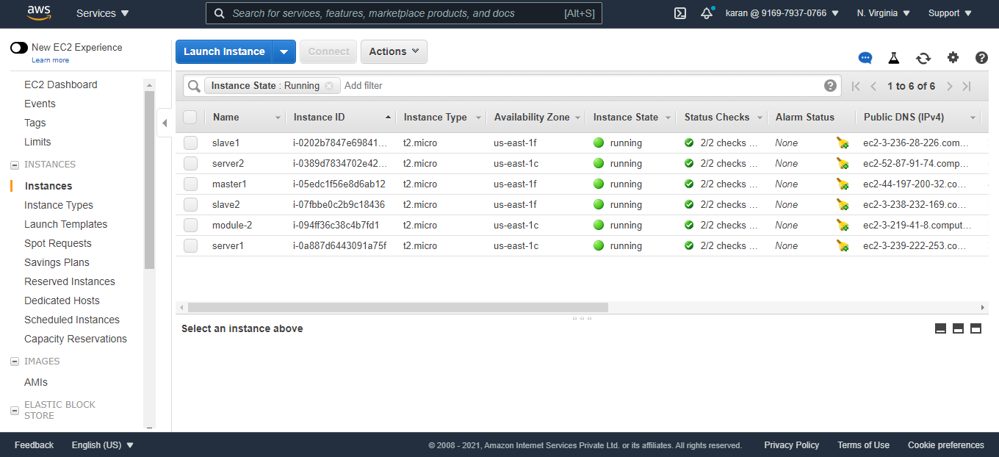

Now we will click on the **Launch instance** link to start creating the new Ubuntu Instance.

So it will be around 5-6 steps that we would be required to complete to create the instance successfully.

**Step 1 :**

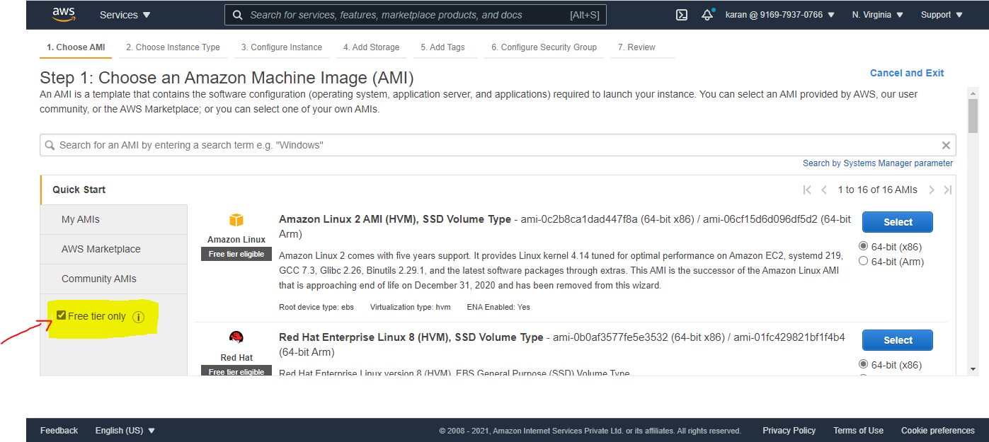

And for the course you can use a free tier and hope all are working on a free tier account, **so make sure you click on the free tier only checkbox as shown in Image above.**

**NOTE:** Using the non-free services will be charged.

We will now look for the **Ubuntu server AMI** (Amazon Machine Image) and proceed to the next step.

Image:

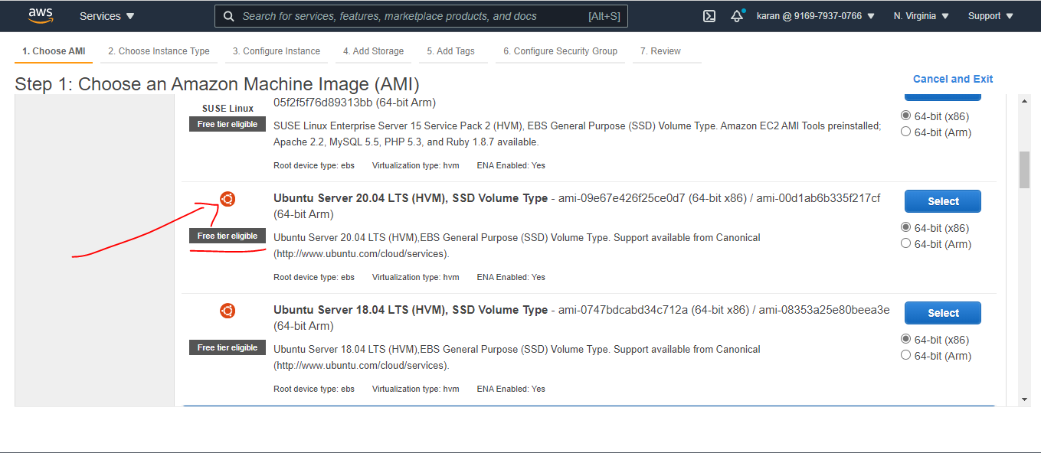

**Step 2:** Here we will be selecting the **free tier eligible instance** i.e **t2.micro** for the completion of the assignment.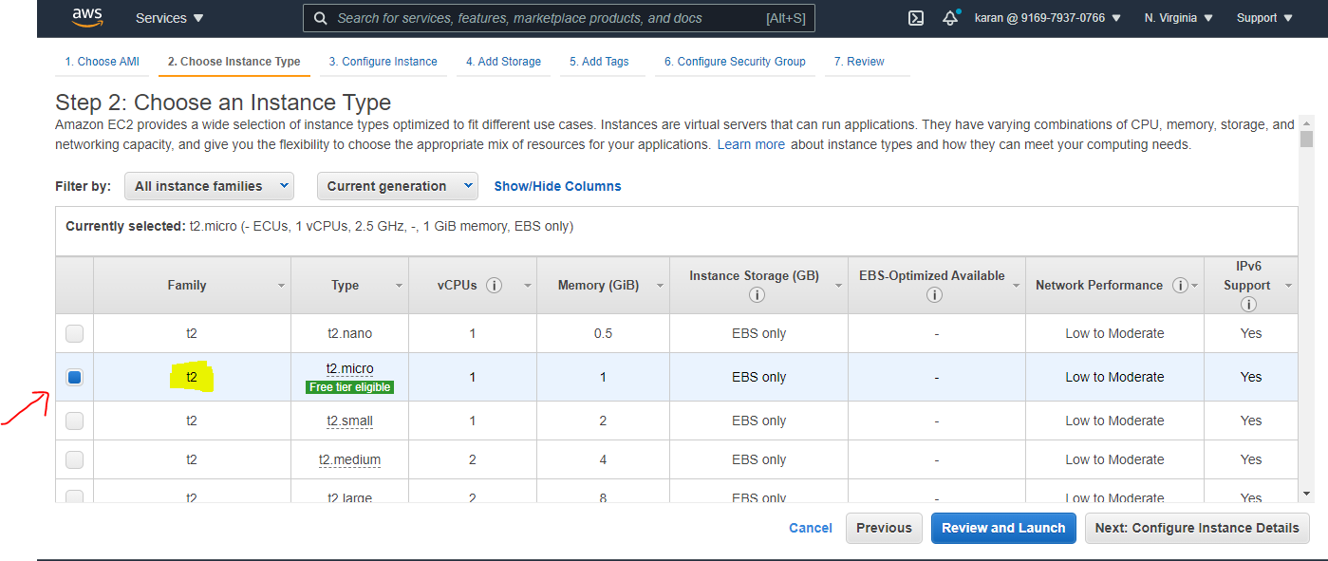

Proceed to the next Step

**Step 3:**

Configuring the Instance details, here we will be **leaving it to the defaults** as no special requirements are to be fulfilled in this section, just moving to the next step.

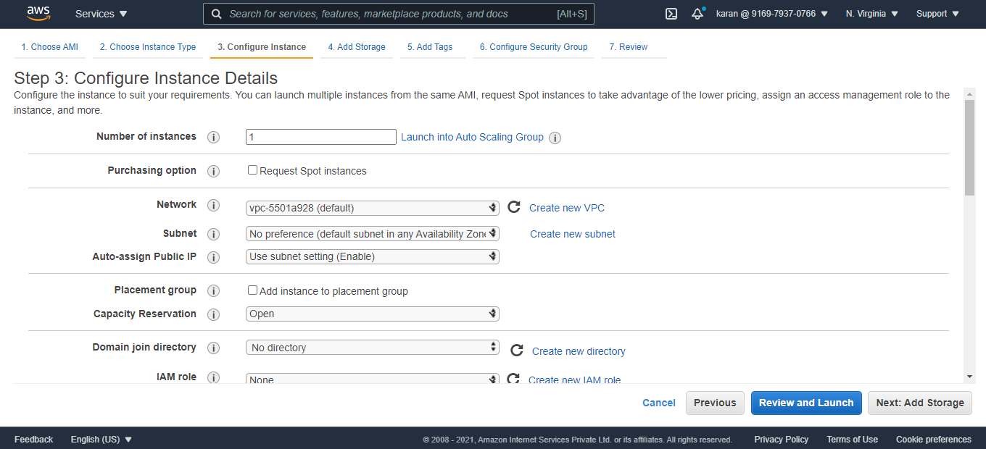

**Step 4:**

Add storage step is also not required to be edited, **the defaults will do the thing for this assignment.**

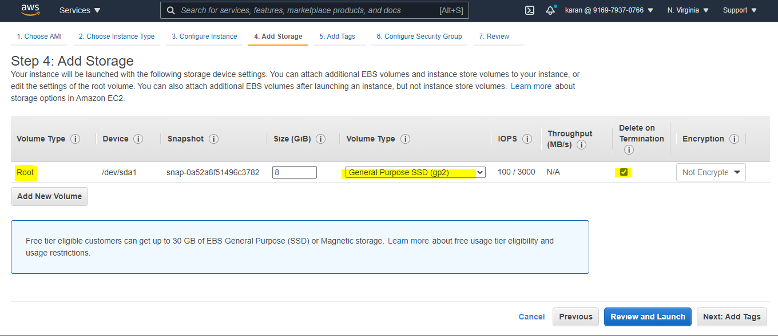

The general purpose SSD is the volume type that we will select.

**Step 5:**

The Add tags section is the step which can be counted as the **Optional Section.**

Each tag is a label consisting of a user-defined key and value Tags can help you manage, identify, organize, search for, and filter resources.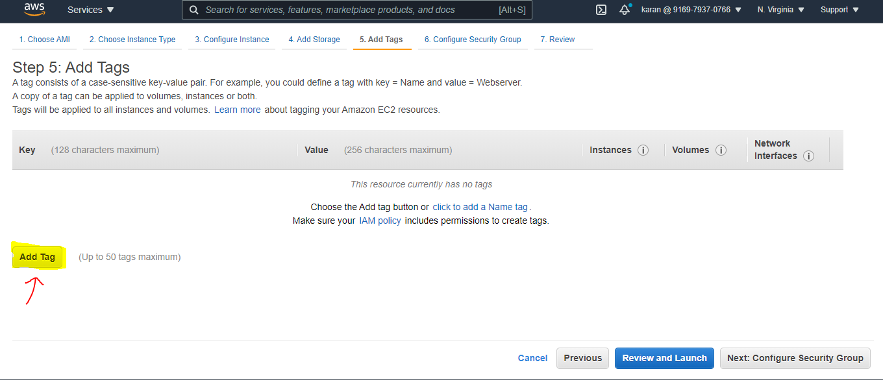

Example:

We have added **demo** as key and value for our instance as that is what the purpose of this instance is.

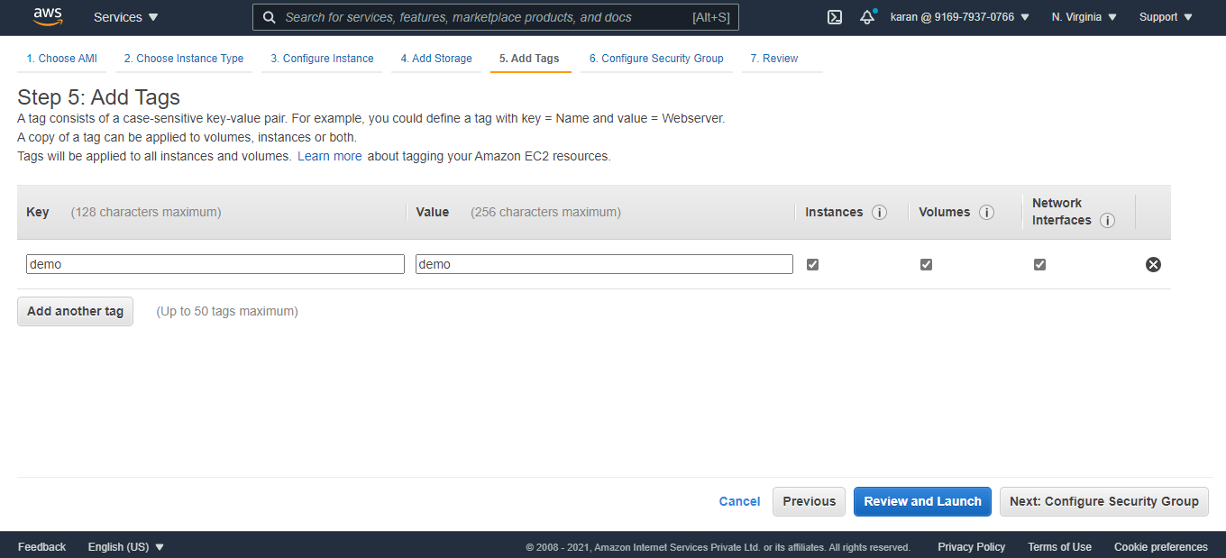

**Step 6:**

The next step is where we will be focusing on the access and security of our new instance that we are creating. The access points and protocols that will help us connect to the instance session and services.

Here we can see in the image below **SSH already added**, so that we can log in to the instance using the SSH client, similarly **we can select more protocols like HTTP/HTTPS** so we can access the service on our webpage. Or allow all traffic also is an option depending on your requirements, *for the assignment go with* **All Traffic** *option.*

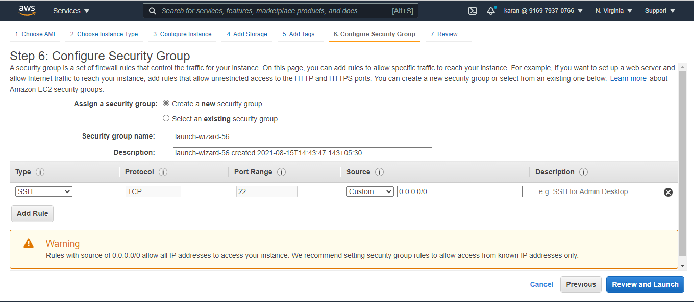

Now we go on **Review and Launch** link and start with the review of the specifications we have set. Now we need to get a key pair for our Instance and go ahead with that, it shows us select from existing key pairs but we will be creating a new key pair and give it a name for your reference.

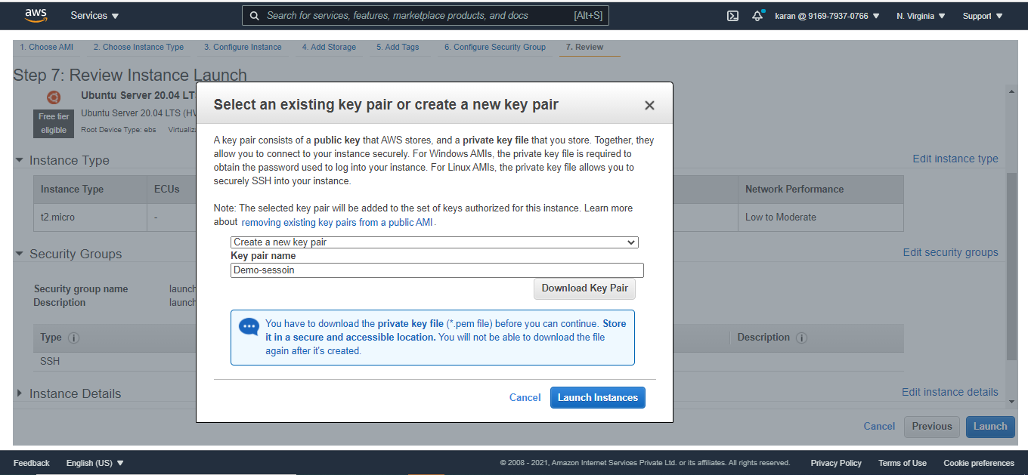

Now after this step we click on **Launch Instances.**

Now the following screen will be displayed to you. It will state that your instances are now launching.

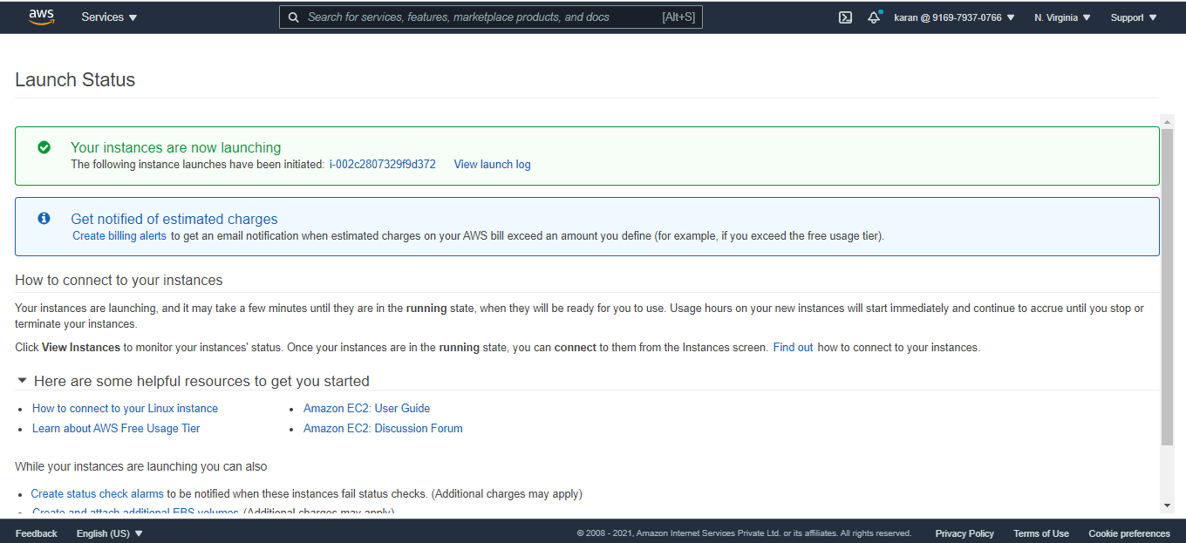

Now we have successfully created and launched our Ubuntu server/instance.

We can verify it on the **Running Instances** page. We see our instance running by the name **Session Demo.**

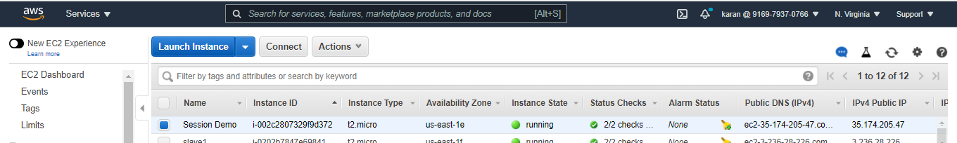

Now we need to connect to our instance to install NGINX in the instance and for that we will need to convert our public key that we downloaded to the .ppk file the private key.

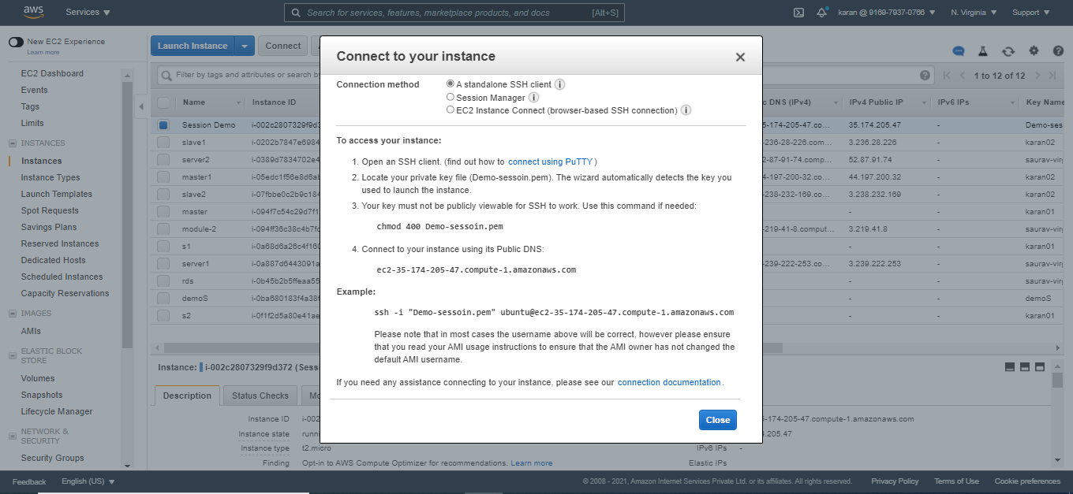

For that we need **Putty** and **PuttyGen Application** to start.

First we open our **PuttyGen Application** and then load our download key file on this.

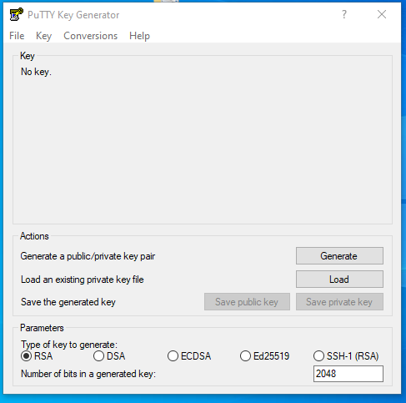

After we have loaded the file in it, we will see a **success pop-up** message,

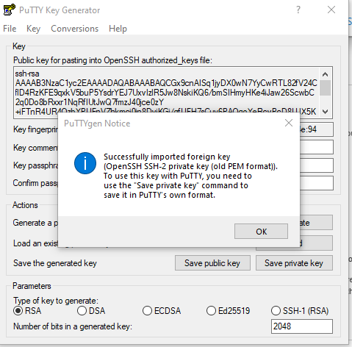

After closing this pop-up we will have two options , **Save public key** and **Save private key**,

We need to download the **Private key** and this **.ppk** file will be required to connect to our instance using the putty application.

Now we open our Putty application after we have successfully downloaded our **.ppk Private key**, after opening the Putty application we can see a **Hostname field**, we require this field.

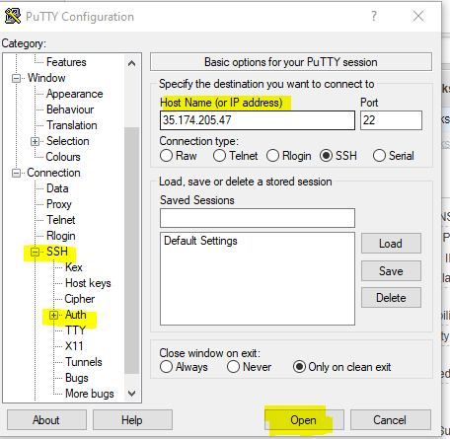

Now in the **Hostname Field** we need to enter the **IPv4 address of our instance that we just created,** the Ubuntu instance.

To **see the IPv4 address** of your instance go to the **Instances page on your AWS portal**, And *Click on your instance and there in the description below, you can see the field of IPv4 and copy it and paste it to the* ***Hostname field.***

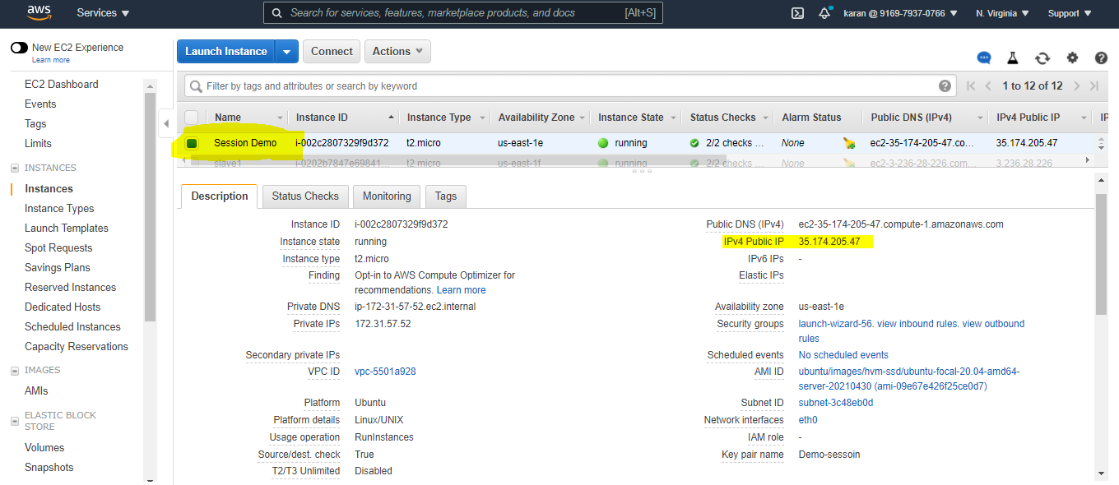

Now the next step would be to open the **SSH** option **on the left**, and then click **Auth.** 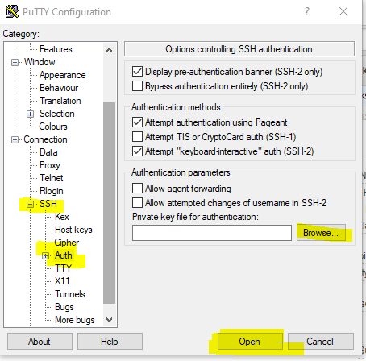

Now we see and option to **browse our file,** this is the field where we need to **upload our .ppk file (private key).**

**NOTE: Now here you might not see your .ppk file on browsing, you need to change files to All Files,** and now you might be able to see your file where you previously saved it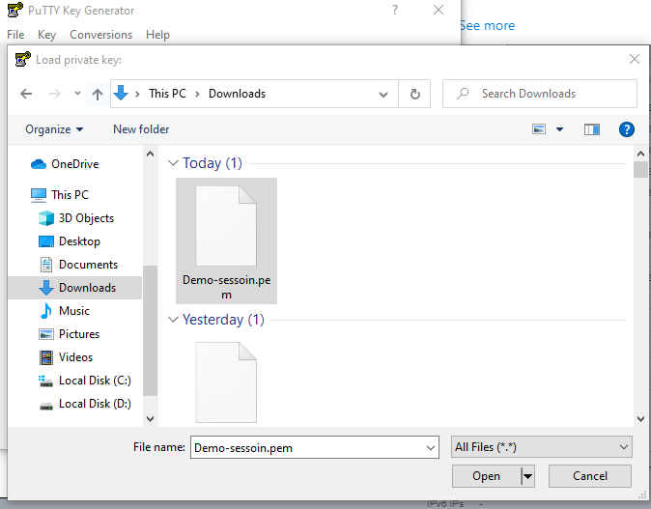

Now on the login screen on the terminal we need to enter the **username** we will be using to login in the system**.** So here we will be using **ubuntu** as the **username** and after entering the **ubuntu as username** we will be successfully entered into the console/terminal.

